Dr. Simon Antony Roberts
10/466 Illawarra Rd,
Marrickville, NSW, 2204
+61-8-61027992
simonxaies@gmail.com

My Critically Insane Doctor
155-157 Livingstone Rd,
Marrickville, NSW, 2204
BH: +61-2-9562 0500
Fax: +61-2-9562 0501

To Simon Antony Roberts – Critically Insane Doctors,

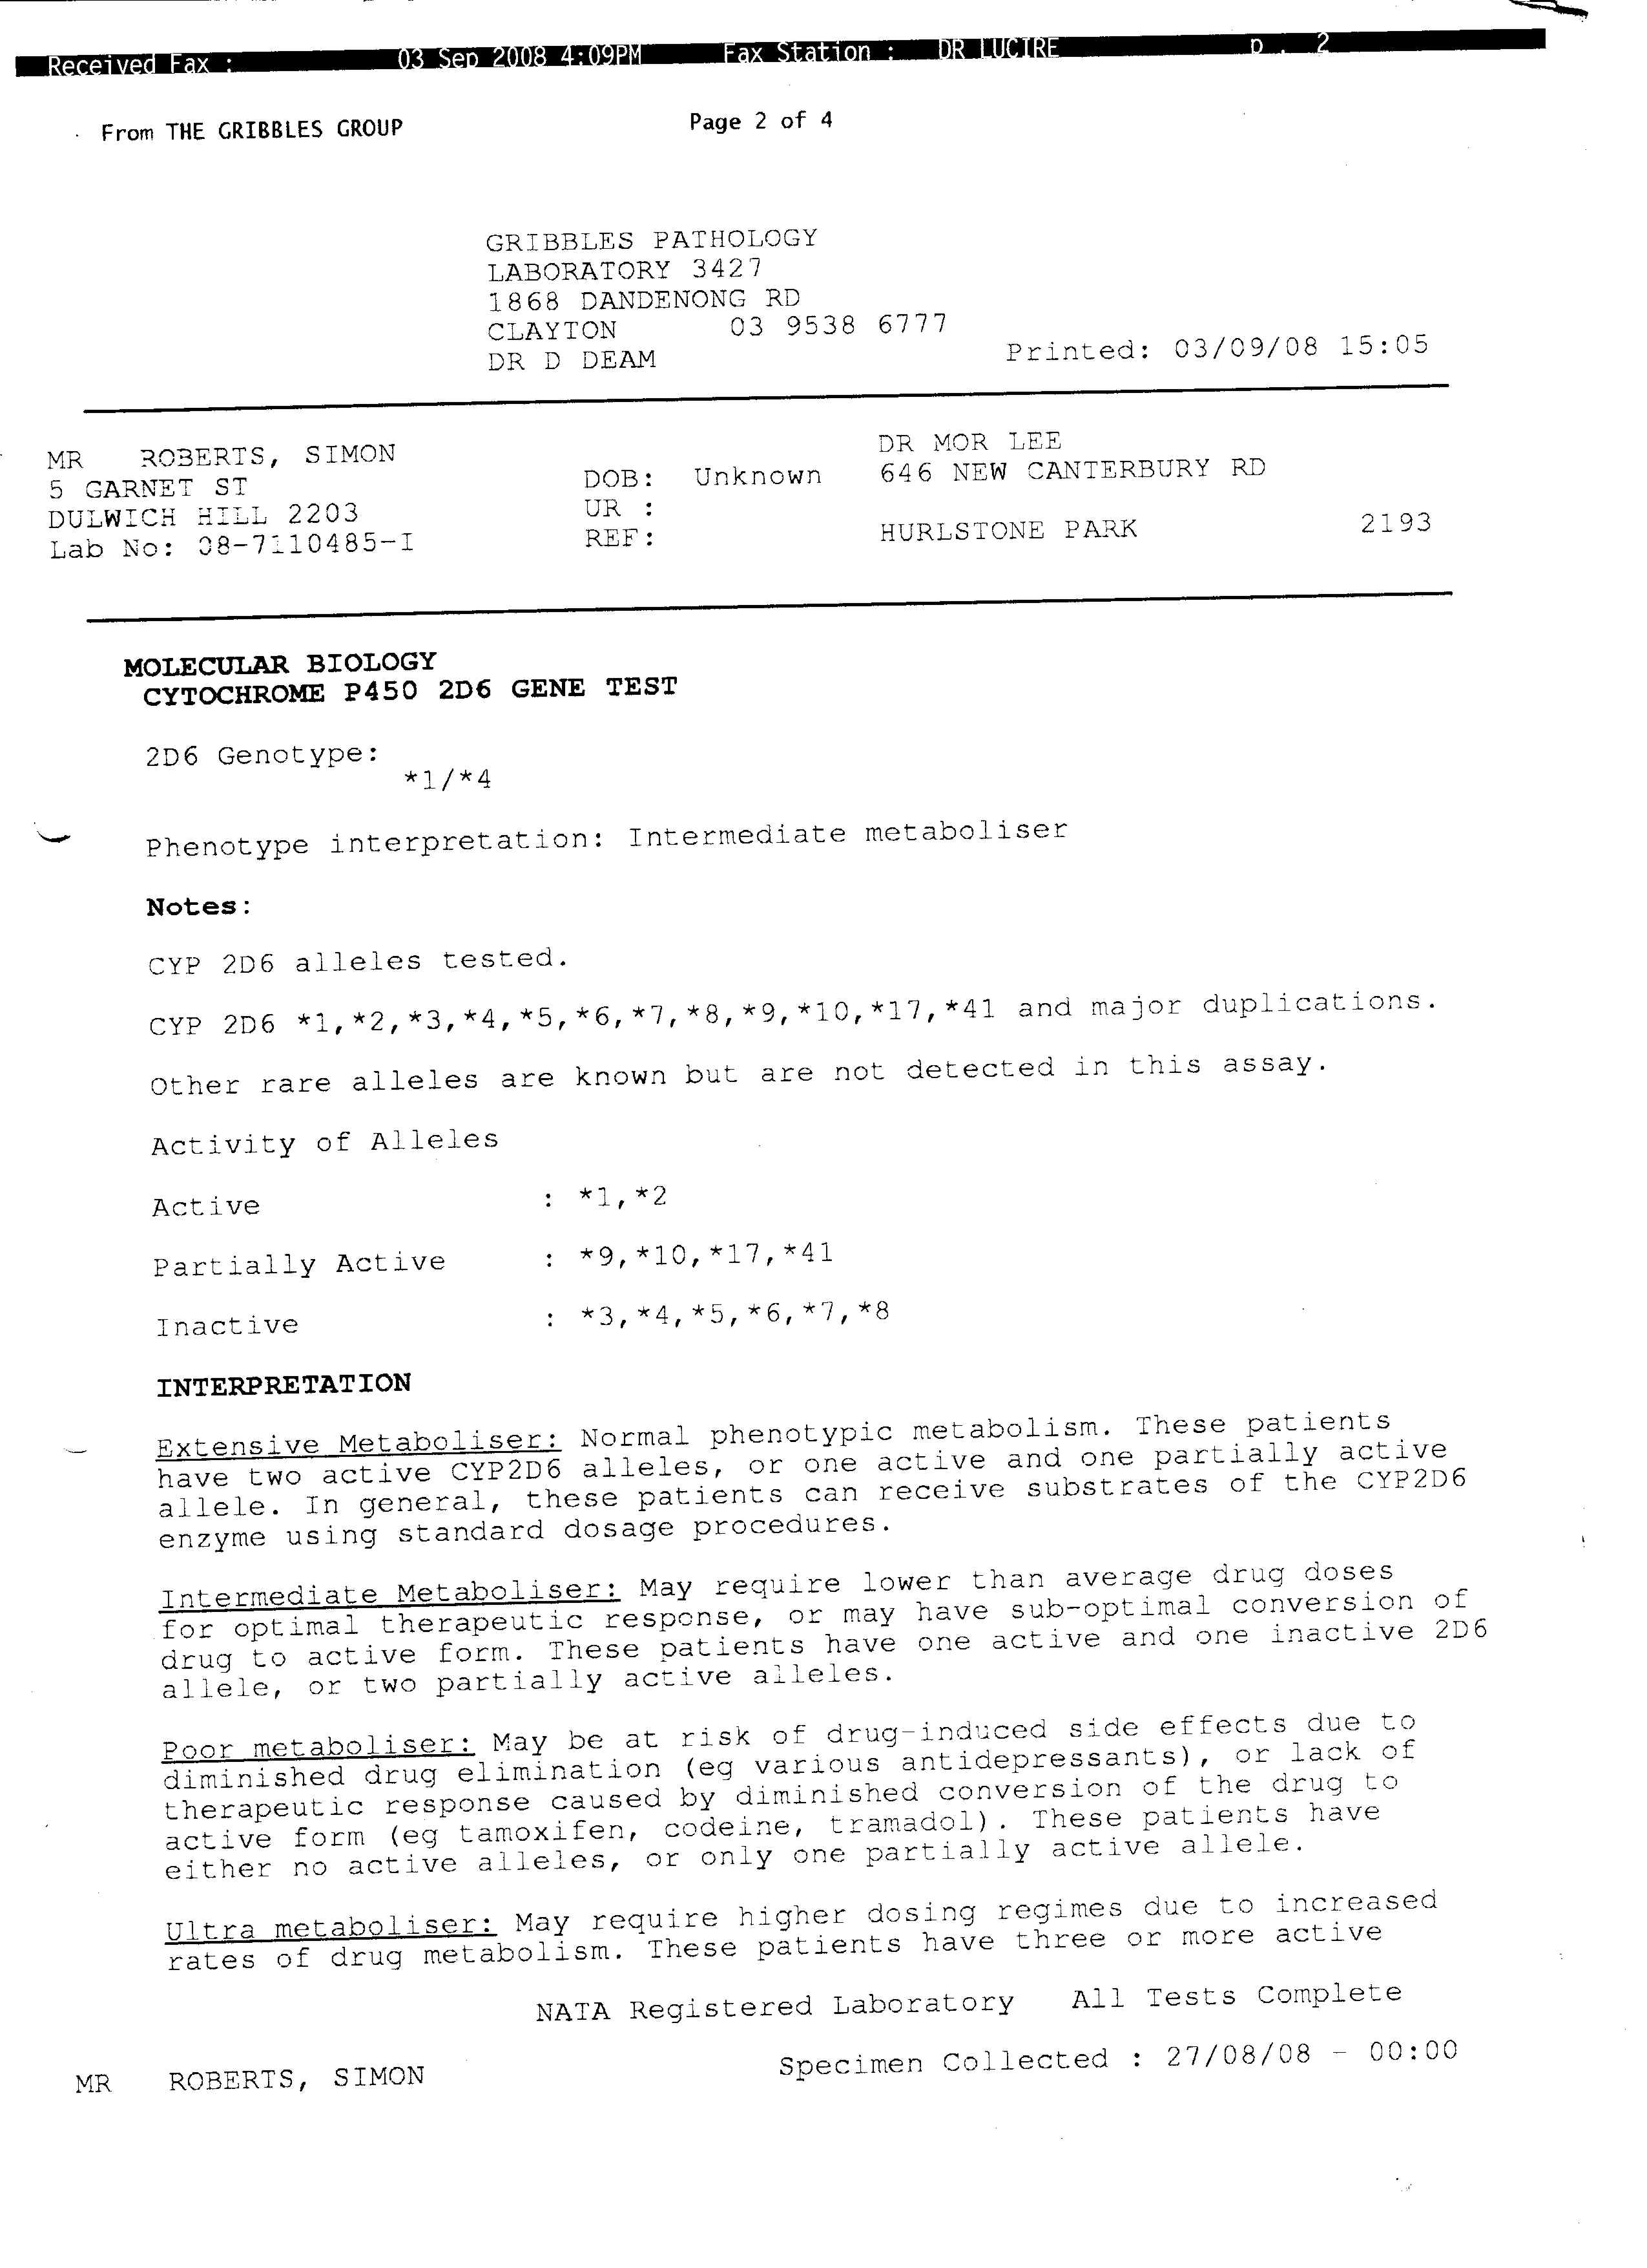
It has become apparent that you have no ability to be communicate with at least with the inner west mental health service even through your own education system it is as if you are stone deaf, dumb and blind to Dr. Simon Antony Roberts both secondary consaultancy who did a CYP450 test (left below – page 2) to the mental health medicolegal services of Dr. Yolande Lucire (drlucire.com) who ran this saliva test that is important to do every case that is ever even consider prescribed to even to start with mental health and as you can see on the CYP2D6 alleles tested.

Dr. S. A. Roberts not only doesn’t have CYP2*D3 + CYP2*D4 + CYP2*D5 + CYP2*D6 + CYP2*D7 + CYP2*D8 where everything you have in the cupboard only works with these normally only CYP2*D6, she’ll only has CYP2*D1 + CYP2*D2 not only do you notice what Dr. Roberts also used the secondary buckle swabs for making 4 of them sent to gribbles see that dob: unknown perposefully put that there on a verified as you will see in the 28 copies of the four pages you have repeatably been given that is on file.

All you have produced throughout your entire medical history with Dr. S. A. Roberts is an adverse reaction you have never in the history off applied medical science even in the slightest produced a treatment or solution to your problem Dr. S. A. Roberts is not human, she’ll entire family if fake entirely; Dr. Simon Antony Roberts if you check 1/1/1901 on M8747409 has an open Area 51 report that declassified article say the following.

You must never subderminally inject this passport holder, there must only be if ever intravenously by simon’s own hand! Simple because Dr. S. A. Roberts predates in carbon history your entire civilation from before terraforming Real Earth the very existence of whtat you are doens’t predate Dr. Simon Antony Roberts or she’ll partner Elpiniki Isoif who both on carbon date stamping saliva. Tales the full 50 days passing one test which is -99999999999999999999 in year count.

Now why are we refering; to your patient Doctor, well simply you can’t even do your research at all; if you goto Dr. Simon Anony Roberts facebook www.facebook.com/SimonSXaies Simon’s second name is Sadisiticia or unslapped as the era they are going through on their homeworld it normally Stephanie. Goto → About → Education and look to see that Dr. Simon Antony Roberts since you came to door has a Masters since 2008 in IT, Physics + Psychology making she’ll as a psychaitrist as well as home turf what called there a Conscious Architect.

Now at some point of your injecting your going to have exploding baby people suffocationg and drowning in oxygen environment and so on.

Have a great Day
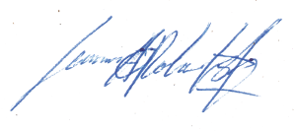

Dr. Simon A. Roberts / Gc. Simon S. Xaies
Phone Number: + 61861027992
Skype: antony.cipher
Email: simon@snails.email
Email: dr.x@ordinance.space
Email: wishcraft@users.sourceforge.net
Personal Twitter: https://twitter.com/SimonXaies
Personal Facebook: https://facebook.com/SimonSXaies
Personal Linked-in: https://www.linkedin.com/in/founderprinciple
Personal Blogging: https://internetfounder.wordpress.com
SF Open Source: https://sourceforge.net/projects/chronolabs-cooperative
SF Open Source: https://sourceforge.net/projects/vcf5
SF Open Source: https://sourceforge.net/projects/distancesid
SF Open Source: https://sourceforge.net/projects/eight-bit-institute/
GitHUB Open Source: https://github.com/Chronolabs-Cooperative

